**Spike Report: Setting up a Cloud-Based Development Environment for Students using GitHub Codespaces for Ontrack Deployment**

**Introduction:**

To address the challenges students face in configuring local development environments, we're exploring the feasibility of using GitHub Codespaces. This report details the steps for deploying Ontrack within this cloud-based development environment, including associated costs.

**Procedure:**

1. **Sign Up for GitHub Codespaces**:
   * Navigate to <https://github.com/features/codespaces>.
   * If not already done, sign up for the service.

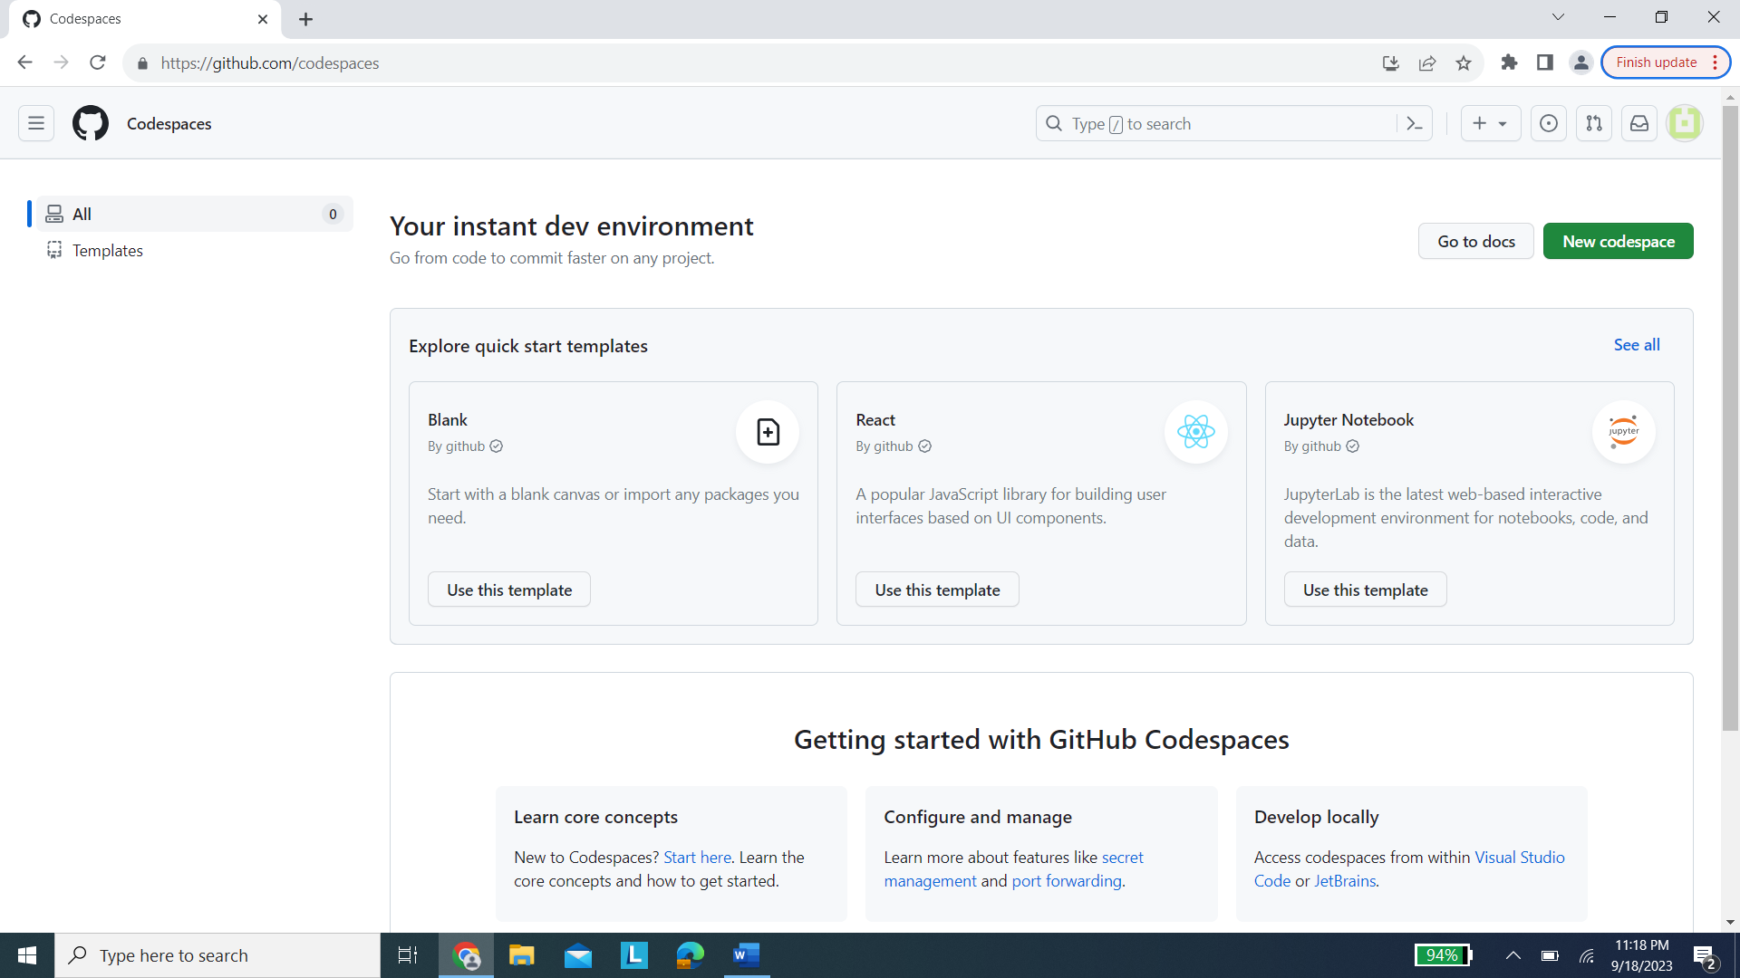

1. **Deploy Ontrack Repository in Codespace**:
   * Fork or clone the Ontrack repository to your GitHub account.
   * Initiate a new Codespace for the Ontrack repository.

1. **Configuring the Development Environment**:
   * Use a **.devcontainer** directory in the repository's root to define and customize the environment.
   * Install all necessary dependencies for Ontrack.

1. **Run and Deploy Ontrack**:
   * Once the environment is set, run the Ontrack application.
   * Ensure its functionality and make necessary configurations for deployment.

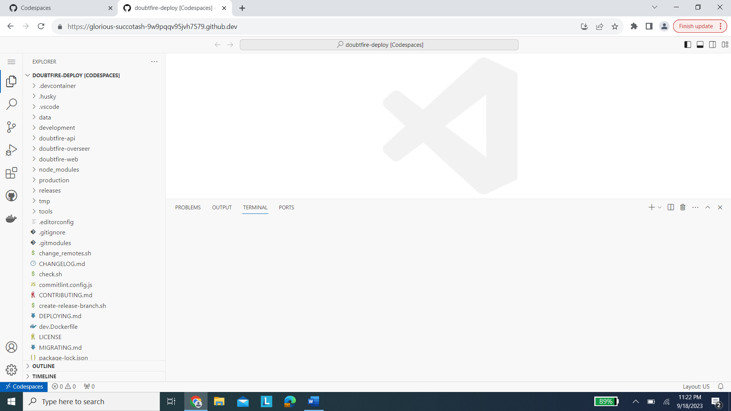

After these steps the ontrack backend and frontend will load and run on their respective ports.

**Cost Implications:**

* GitHub Codespaces is billed per hour.
* These costs can accumulate with prolonged development and multiple students, so cost management is crucial.
* 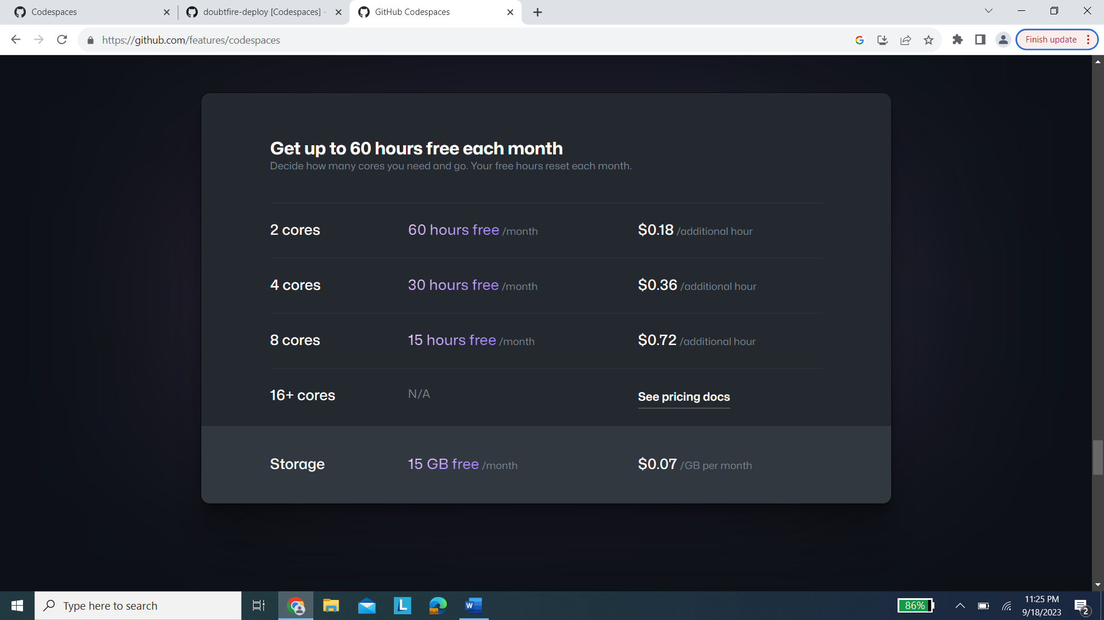

**Conclusion:**

Deploying Ontrack on GitHub Codespaces offers a streamlined solution for students. The combined benefits of ease of setup, consistent development environments, and remote accessibility make it a worthy consideration for educational institutions.

However, while cost-effective for individual developers, institutions must strategize to manage costs when scaling to a larger student body.